Nous avons appris à chanter Frère Jacques et aussi Joyeux anniversaire en anglais. Nous aimons bien les chanter. C’est rigolo

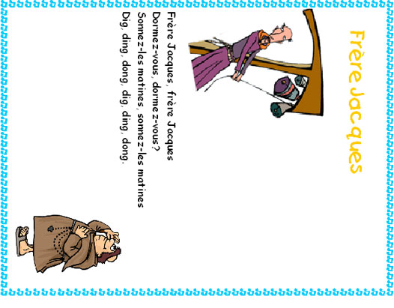
Are You Sleeping?

(Brother Jack)
Are you sleeping?
Are you sleeping?
Brother Jack,
Brother Jack?
Morning bells are ringing.
Morning bells are ringing.
Ding, dang, dong.
Ding, dang, dong.

Happy Birthday to You Joyeux anniversaire
Happy birthday to you! Joyeux anniversaire!
Happy birthday to you! Joyeux anniversaire!
Happy birthday dear [name]! Joyeux anniversaire (prénom)!
Happy birthday to you! Joyeux anniversaire!

